**8th Grade 1st Semester FINAL EXAM**

|  |
| --- |
| **Formulas:** Vcylinder=πr2h Vsphere = πr3 Vcone = π r2h Pythagorean: a2 + b2 = c2 Use 3.14 for π |

**Multiple Choice**

*Identify the choice that best completes the statement or answers the question.*

____ 1. Complete the equation by supplying the missing exponent.

*x* 

|  |  |  |  |
| --- | --- | --- | --- |
| 1. 8 | 1. -3 | 1. -8 | 1. 4 |

____ 2. Simplify the expression 5y6 2y8

1. 10y48 b. 10y14 c. 7y48 d. 7y14

____ 3. A microscope can magnify a specimen 104 times. How many times is that?

|  |  |
| --- | --- |
| 1. 40,000 times | 1. 10,000 times |
| 1. 40 times | 1. 1,000 times |

____ 4. Write the number 230,000 in scientific notation.

|  |  |  |  |  |  |  |  |  |  |  |  |  |  |  |  |
| --- | --- | --- | --- | --- | --- | --- | --- | --- | --- | --- | --- | --- | --- | --- | --- |
| |  |  |  |  |  |  |  |  | | --- | --- | --- | --- | --- | --- | --- | --- | | a. | 0.23 x 106 | b. | 2.3 x 106 | c. | 2.3 x 105 | d. | 23 x 104 | |  |  |  |  |  |  |  |

____ 5. Evaluate.

|  |  |  |  |  |  |  |  |
| --- | --- | --- | --- | --- | --- | --- | --- |
| a. | –36 | b. |  | c. | – | d. | 36 |

____ 6. Solve x3 = 125

|  |  |  |  |  |  |
| --- | --- | --- | --- | --- | --- |
| a. | x = 2 | b. | x = 4 | c. x = 3 | d. x = 5 |

____ 7. List the following numbers in order from least to greatest.

, and 

1. a. ,  and 

b., and 

c., and 

d., and 

____ 8. How many solutions does the following equation have 2(3x + 11) = 6x + 22.

a. one solution c. infinite solutions

b. no solutions d. none of the above

____ 9. Combine like terms. 8*x* + 5*z* – 4*x* + 3*z* + 6.

|  |  |  |  |
| --- | --- | --- | --- |
| a. | 4x + 8z | c. | 4*x* + 8*z* + 6 |
| b. | -32x + 15z + 6 | d. | 12*x* + 2*z* + 6 |

____ 10. Evaluate.

|  |  |  |  |  |  |  |  |
| --- | --- | --- | --- | --- | --- | --- | --- |
| a. | 0 | b. | 22 | c. | –4 | d. | 4 |

____ 11. Classify the number  as rational, irrational, or not a real number.

|  |  |  |  |  |  |
| --- | --- | --- | --- | --- | --- |
| a. | irrational | b. | not a real number | c. | rational |

____ 12. The attendance at a parade was  people. The attendance at a rally was  people. Which event had the higher attendance?

|  |  |  |  |
| --- | --- | --- | --- |
| a. | rally | b. | parade |

____ 13. Find the distance between the two points.

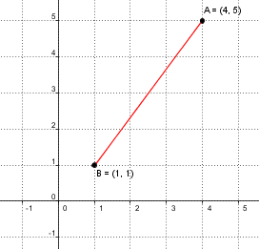

|  |  |  |  |
| --- | --- | --- | --- |
| a. | 6 units | c. | 7 units |
| b. | 4 units | d. | 5 units |

____ 14. A cylindrical container of potatoes has a radius of 5 cm and a height of 9 cm. Find the volume of the container of potatoes. Give your answer in terms of **.

|  |  |  |  |
| --- | --- | --- | --- |
| a. | 225** cm3 | c. | 706.5** cm3 |
| b. | 544.5** cm3 | d. | 900** cm3 |

____ 15. Solve. 8*a* – 10 = 6*a*

|  |  |  |  |
| --- | --- | --- | --- |
| a. | *a* = –0.3 | c. | *a* = 2 |
| b. | *a* = 5 | d. | *a* = 0 |

____ 16. Write the number  in standard notation.

|  |  |  |  |  |  |  |  |
| --- | --- | --- | --- | --- | --- | --- | --- |
| a. | 0.0000991 | b. | 9,910,000 | c. | 0.00000991 | d. | 0.000000991 |

____ 17. Solve 

|  |  |  |  |
| --- | --- | --- | --- |
| a. | 2 | c. | 3 |
| b. | 4 | d. | 5 |

____ 18. Determine if the graph represents a function. Tell whether it is linear of nonlinear.



a. The relationship is not a function. It is nonlinear. c. The relationship is a function. It is nonlinear.

b. The relationship is not a function. It is linear. d. The relationship is a function. It is linear.

____ 19. The square root  is between two integers. Name the integers.

|  |  |  |  |  |  |  |  |
| --- | --- | --- | --- | --- | --- | --- | --- |
| a. | 102, 104 | b. | 15, 16 | c. | 10, 11 | d. | 25, 26 |

____ 20. Is it a function or not?

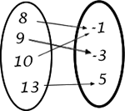

a. Yes, it is a function.

b. No, it is not a function.

c. There is not enough information.

____ 21. What is the range of the function above in question #20?

a. 8, 9, 10, 13 b. -1, -3, 5

____ 22. Find the length of the hypotenuse. Round your answer to the nearest tenth.

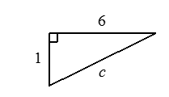

|  |  |  |  |
| --- | --- | --- | --- |
| 1. 6.1 units | 1. 37 units | 1. 7 units | 1. 2.6 units |

_____ 23. Frankie measured large and small items in her science lab. She needed to multiply

5.4 x 103 cm by 8.1 x 105 cm. What is her correct result in scientific notation?

|  |  |  |  |  |  |  |  |
| --- | --- | --- | --- | --- | --- | --- | --- |
| a. | 4.374 x 109 | b. | 4.374 x 1015 | c. | 43.74 x 108 | d. | 43.74 x 1015 |

____ 24. A square room has a tiled floor with 81 square tiles. How many tiles are along an edge of the room?

|  |  |  |  |  |  |  |  |
| --- | --- | --- | --- | --- | --- | --- | --- |
| a. | 9 tiles | b. | 11 tiles | c. | 40 tiles | d. | 20 tiles |

____ 25. Find the volume of the figure. Use 3.14 for . If necessary, round your answer to the nearest tenth.

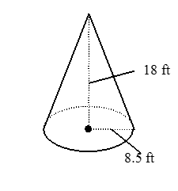

A. 1362.2 ft.3

B. 1502 ft.3

C. 1413 ft.3

D. 1264 ft.3

____ 26. Multiply. Write the product as one power. 

|  |  |  |  |  |  |  |  |
| --- | --- | --- | --- | --- | --- | --- | --- |
| a. ${12}^{10}$ |  | b. | Cannot combine | ${12}^{7}$ |  | ${12}^{3}$ |  |

____ 27. Find the volume of the sphere in terms of . Leave  in your answer.

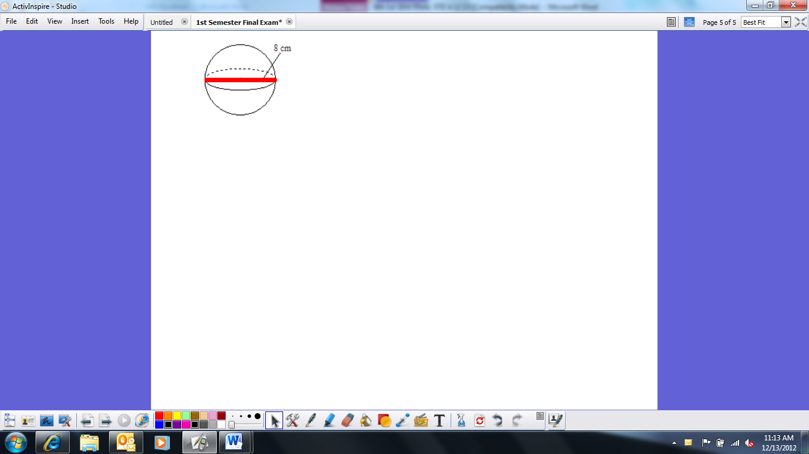

|  |  |  |  |
| --- | --- | --- | --- |
| a. | 64 cm3 | c. | 21.3 cm3 |
| b. | 85.3 cm3 | d. | 256 cm3 |

____ 28. Find the height of a right cone with radius 6 in. and slant 10 in.

|  |  |  |  |
| --- | --- | --- | --- |
| a. | h = 8in | c. | *h* = 16in |
| b. | h = 4in | d. | *h* = 11.6in |

____ 29. Solve .

|  |  |  |  |
| --- | --- | --- | --- |
| a. | *z* = 14 | c. | *z* = 135 |
| b. | *z* = 85 | d. | *z* = 45 |

____ 30. Determine if the relationship represents a function and find the slope (m).

|  |  |
| --- | --- |
| ***x*** | ***y*** |
| 0 | –5 |
| 1 | –1 |
| 2 | 3 |
| 3 | 7 |

a. The relationship is a function (m = 1/4) c. The relationship is not a function (m = 4)

b. The relationship is function (m = 4) d. The relationship is not a function (m = ¼)

____ 31. This relation is not a function because it fails the vertical line test. Where does it fail the test?

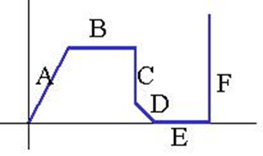

a. A & D c. C

b. B & E d. C & F

____ 32. Find the slope of the line that passes through the points (9, 7) and (2, 9).

|  |  |  |  |
| --- | --- | --- | --- |
|  |  |  |  |

____ 33. What is the y-intercept of the line represented by y = -2x – 4?

|  |  |
| --- | --- |
| 1. -4 |  |
| 1. 4 | 1. 2 |

____ 34. Solve for m:  8(*m* + 5) = 16

|  |  |  |  |
| --- | --- | --- | --- |
|  |  | 1. 3 | 1. -3 |

____ 35. Find the radius of a cone with volume 150.72 ft3 and a height of 9.

|  |  |  |  |
| --- | --- | --- | --- |
| a. | 4 ft | c. | 2.3 ft |
| b. | 3 ft | d. | 16 ft |

____ 36. Determine if the following function is linear or not. f(x) = 3x3 + 5

1. Yes, Linear b. No, Non-linear

_____ 37. Find the missing side length. Round to the tenths place, if necessary.

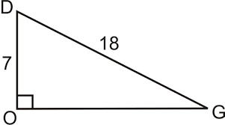

a. 275 c. 16.6

b. 5 d. 25

____ 38. Daniel rides his bicycle 15 km west and then 8km north. How far is her from his starting points?

1. 22 km c. Approximately 12.7 km
2. 17 km d. 7 km

____ 39. Compare the volume of a cylinder to the volume of a cone with the same radius and height.

|  |  |  |  |
| --- | --- | --- | --- |
| a. | The volume of the cylinder will be 3 times larger. | c. | The volume of the cone will be 3 times larger. |
| b. | The volumes will be equivalent. | d. | There is not enough information. |

____ 40. Which function has the greater rate of change?

**Function A** **Function B**

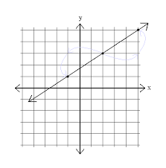

y = ½ x + 3

|  |  |  |  |
| --- | --- | --- | --- |
| a. | Function A has a greater rate of change. | c. | They have the same rate of change. |
| b. | Function B has a greater rate of change. | d. | There is not enough information. |

____ 41. Make a table and a graph of *y* = 4*x* – 3.

|  |  |  |  |
| --- | --- | --- | --- |
| a. |  | c. |  |
| b. |  | d. |  |

**SHORT ANSWER:**

For #42 and 43, write an equation in slope intercept form for each of the questions below.

42.



m = __________

b = __________

Equation: ________________________

43. slope = -2 point (4, 3)

m = __________

b = __________

Equation: ________________________

Answer Key

1. B
2. B
3. A
4. C
5. B
6. D
7. D
8. C
9. D
10. C
11. A
12. A
13. A
14. B
15. C
16. A
17. C
18. B
19. D
20. C
21. C
22. A
23. A
24. C
25. C
26. B
27. A
28. D
29. A
30. B
31. D
32. C
33. D
34. A
35. B
36. A