**` Algebra 1 Final Exam Fall 2017 Name__________________Date**

**SHOW YOUR WORK!!**

1. **Simplify: (2a + 3)(a – 4)**
2. **Simplify: **
3. **Solve: $d=\frac{1}{2}at^{2}$ for t**
4. **Simplify: **
5. **Simplify: **
6. **Simplify: **
7. **The sum of two numbers is nineteen. The difference between five times the larger number and four times the smaller number is twenty-three. Find the two numbers.**

**8. Suppose Kirk has taken three tests and made 88, 90, and 84. Kirk’s teacher tells the class that each test counts the same amount. Kirk wants to know what he needs to make on the fourth test to have an overall average of 90 so he can make an A in the class. What does he have to make on his last test?**

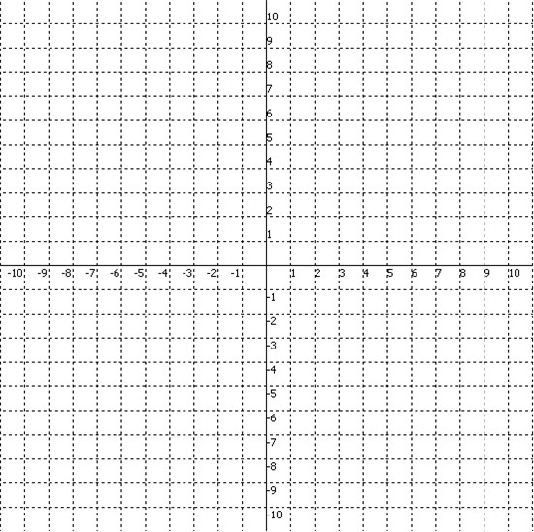

**Identify each of the characteristics**

**9. Graph g(x) = 4(2)x-1 – 3**

**Domain:**

**Range:**

**x-intercept**

**y-intercept**

**Interval of Increase**

**Interval of Decrease**

**Positive**

**Negative**

**Even/Odd/Neither**

**End Behavior:**

**As x🡪 ∞, y🡪**

**As x🡪 -∞, y🡪**

**Asymptote:**